East Africa Branch

14th Annual Dinner and Best Students Award Presentation Gala.
- Date Friday, May 3rd , 2019
- Venue City Blues and Creek Side Hotel – Mombasa Kenya
Overview
The Chairman, Members of the Executive committee and the Secretariat of the Institute of Chartered Shipbrokers East Africa Branch is pleased to invite all members of the Institute globally, Stakeholders, Students and non-members to attend the branch 14th Annual Dinner and Award Presentation Gala on Friday 3rd May 2019 at City Blues and Creek Side Hotel (Formerly known as Best Western and Creek Side Hotel), Kenya. The event is from 18:00 - 21:00.
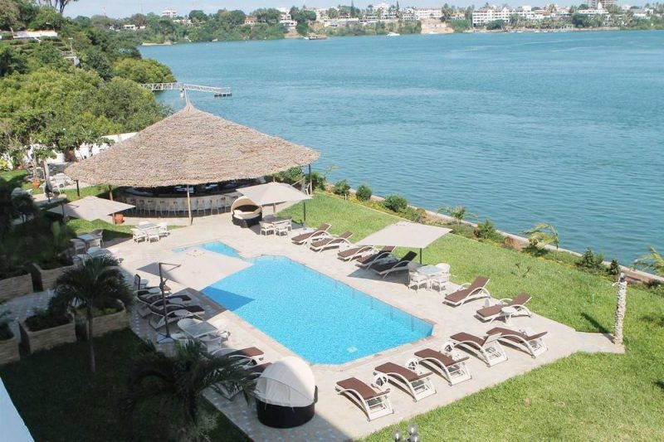
Cost for the Dinner is
- Ksh 3,000 for Non members
- Ksh 2,500 - Members
- Ksh 2,000 - Students
Table rates are as follows;
- Table of 12 guest - Ksh 42,000
- Table of 10 Guest - Ksh 35,500
- Table of 8 Guest - Ksh 28.800
- Table of 6 Guest - Ksh 21,900
- Table of 4 Guest – Ksh 14,800
Included in the table price is the possibility to display your Company Logo during the Dinner. We are planning to have a rolling display of the Logos on a screen during the meal.
There will be a lot of entertainment with good soft music from the band.

Venue Map.
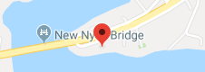

Contact for Event
Institute of Chartered Shipbrokers (ICS) - East Africa Branch.
Off Moi Avenue
Opposite Moi University (Mombasa Campus)
P.O BOX 2095 - 80100
Mombasa - Kenya.
Awindah Oketch, 0721 790 168
Paul Katana, 0731 436 362
events@icseastafrica.org
admin@icseastafrica.org
education@icseastafrica.org

